**SKYHIGH AIRLINE RESERVATION SYSTEM**

DATABASE DESIGNS:

Dbo.Bookings:

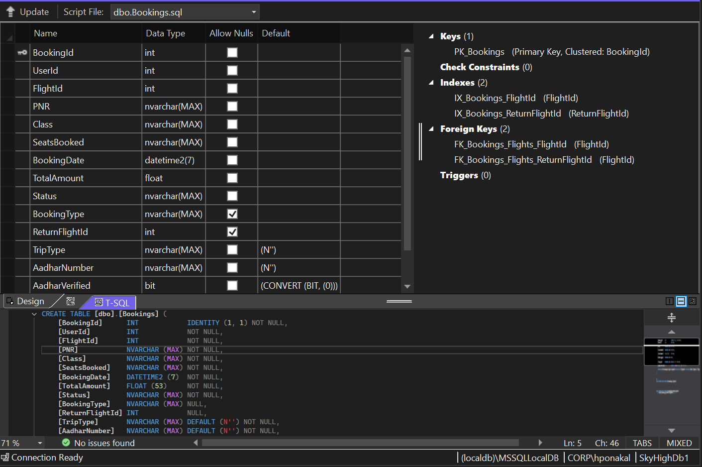

Dbo.ContactMessages:

Dbo.Flights:

Dbo.Passengers:

Dbo.Payments:

Dbo.Seats:

Dbo.Users:

